Annual session 2020
1 to 5 June 2020, New York
Item 4 of the provisional agenda
Ethics

Activities of the UNOPS Ethics and Compliance Office in 2019
Report of the Ethics and Compliance Office

Summary
The UNOPS Ethics and Compliance Officer provides this report annually to the Executive Director. The report is then submitted to the Executive Board at its annual session, pursuant to Board decision 2010/17.
The members of the Ethics Panel of the United Nations reviewed the draft report in March 2020, in accordance with section 5.4 of the United Nations system-wide application of ethics in the separately administered organs and programmes (ST/SGB/2007/11, as amended). The UNOPS Audit Advisory Committee reviewed the draft report at its 25 March 2020 meeting. The report covers the period from 1 January 2019 to 31 December 2019.
This is the eleventh annual report presented by the Ethics and Compliance Office (formerly the Ethics Office) since its establishment in 2009.
Elements of a decision
The Executive Board may wish to take note of the present report and comment on progress made by the UNOPS Ethics and Compliance Office in strengthening the ethical culture of UNOPS.

Contents

Chapter Page
I Introduction 3
II Report on 2019 activities 3
Protection against retaliation 5
Policy and standard setting 8
Training and awareness raising 9
Financial disclosure programme 10
Advice and guidance 11
Other 13
III Development of the Ethics and Compliance Office, 2019-2020 13
IV The Ethics Panel of the United Nations and the Ethics Network of Multilateral Organizations 14

Introduction
- This report is submitted in accordance with Executive Board decision 2010/17 and covers the activities of the UNOPS Ethics and Compliance Office in 2019. The report is submitted to the Executive Director of UNOPS and the Executive Board of UNDP, UNFPA and UNOPS.
- The office was established in 2009 pursuant to Secretary-General’s Bulletin ST/SGB/2007/11 as amended. The office is based in Copenhagen and provides ethics and compliance support to UNOPS personnel globally across its operations in more than 80 countries (approximately 4,750 in 2019).
- Pursuant to the bulletin, the office’s mandate is to “cultivate and nurture a culture of ethics, integrity and accountability, and thereby enhance the trust in and credibility of the United Nations, both internally and externally.” Under the bulletin, the office has specific responsibility for:
  - developing standards, training and education on ethics issues;
  - providing guidance to management to ensure UNOPS rules promote integrity standards;
  - providing confidential advice and guidance to personnel on ethical issues;
  - raising awareness on ethical standards and expected behaviour;
  - managing UNOPS protection against retaliation policy; and
  - administering UNOPS financial disclosure programme.
- Additionally, the Chief Ethics and Compliance Officer, who leads the office, serves as a member of the Ethics Panel of the United Nations (EPUN) in order to support ethics standard-setting and policy coherence within the United Nations Secretariat and the other separately administered organs and programmes. The office also participates in the Ethics Network of Multilateral Organizations (ENMO) in order to exchange information and collaborate on issues of common interest with other multilateral intergovernmental institutions.
- On 27 December 2018, UNOPS leadership determined to broaden the focus of the Ethics Office (as it was then called) to include compliance. In particular, the office now has a mandate to implement and maintain a framework to ensure policies and procedures are fit for purpose and materially complied with. The office welcomes this decision as it enables UNOPS, through the work of the office and in collaboration with management, to further strengthen the culture of integrity, ensure that ethics is positioned properly within the organization and is addressing the ethical challenges of today, and drive greater levels of accountability. Even with the expansion of its role, the office continues to act with independence, impartiality and confidentiality, as stipulated in the bulletin. In addition, in 2019, further to the Executive Director’s decision in mid-2018 to increase the resources dedicated to the programme, UNOPS hired a new director to lead the office. The director, referred to by the standard professional title of Chief Ethics and Compliance Officer, joined UNOPS in August 2019.
- Overall, 2019 marks an important milestone in UNOPS approach to ethics as the organization has made a clear decision to ensure it has a robust ethics and compliance programme, which will proactively identify and develop mitigation strategies for the key ethical risks faced by the organization today. This recognition by UNOPS leadership is founded on the understanding that delivering UNOPS’ work ethically is both the right thing to do and vital for maintaining stakeholder trust and ongoing relationships. As it develops its work into 2020, the Office will extend its focus to broader institutional integrity matters. The office welcomes the increased strategic focus and investment of time and resources to ethical issues and is grateful for the support of the UNOPS Senior Leadership Team, which is critical to ensuring the success of the programme.

Report on 2019 activities
- In 2019, the office continued to provide services across a broad range of areas, as shown in figure 1. Notable activities in the first half of 2019 included an increase in the provision of ethics advice, with the office building on its reputation as a source of valued, confidential advice; the consolidation of its new styled financial disclosure and conflicts of interest programme; and the roll out of targeted training on key ethics topics. Following the arrival of the Chief Ethics and Compliance Officer, the office focused extensively in the second half of 2019 on developing its workplan to further develop the ethics and compliance programme with an increased emphasis on institutional integrity. The Chief Ethics and Compliance Officer has built positive working relationships with the Executive Director and the members of the senior leadership team, attending their meetings quarterly on an ex-officio basis to provide enhanced awareness within the leadership team of the nature of important issues arising, while respecting the office’s independence and obligations of confidentiality.
Figure 1. Breakdown of requests for services by category: 2019
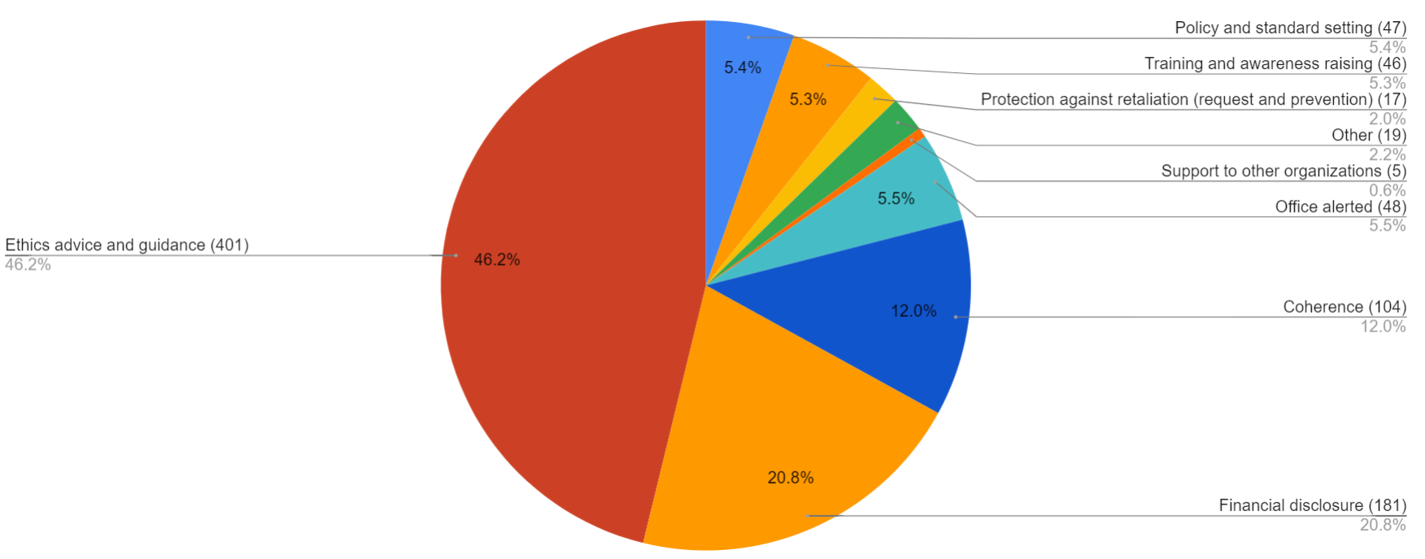
- There was a slight drop in overall request numbers in 2019, which has been increasing steadily since 2016. In 2019, the office handled 868 cases, a fall from the 1,055 received in 2018. As seen in figure 2, case volume is still significantly higher than in the period 2010 to 2015, when it varied between 400 and 500 per year. It is important to note that raw case numbers do not provide any indication of time spent on any particular matter, since different cases have differing levels of complexity and workload. Importantly, the decrease in case numbers relates only to the non-advice side of the office's work. By contrast, case numbers on advice matters continued to rise in 2019, demonstrating the continuing trend of personnel confidence in the office to provide guidance on ethical issues.

Figure 2. Comparison of requests for services by reporting cycle: 2015-2019

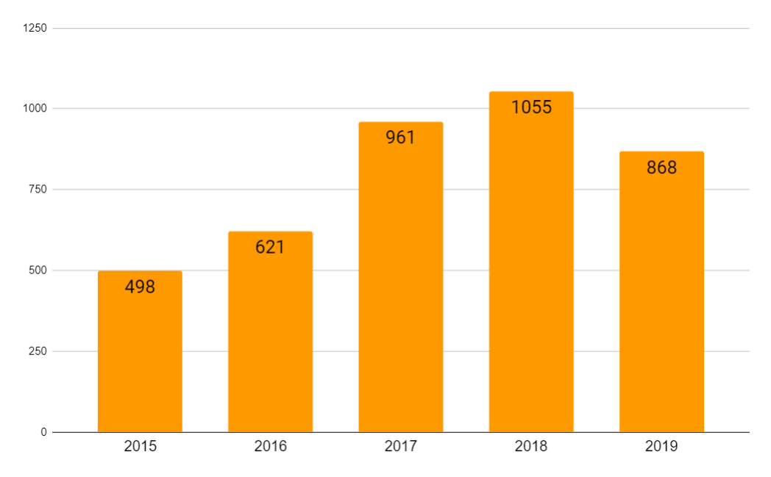

- The number of requests for advice increased from 343 in 2018 to 401 in 2019. The office is now increasingly solicited for advice; advice requests represented 46 per cent of the total in 2019 (against approximately 33 per cent in 2018 and 2017). The increased demand for advice is also reflected in the greater visibility of the office as reflected in the results of the people survey conducted in 2019. The office believes this is due to its progressive shift to a more proactive stance, enabled through its expansion beginning in late 2015. This trend is expected to continue.
- The two categories of services where case numbers fell most significantly were policy and standard setting (47 in 2019 and 161 in 2018) and services in respect of the financial disclosure programme process (181 in 2019 and 232 in 2018). The office believes the lower number of cases in standard setting is attributable to the more established policy environment in UNOPS of 2019, following the comprehensive revision of the UNOPS-wide policy framework from 2017 and 2018. The financial disclosure programme process category covers process-related actions, including responding to queries from colleagues about filing. The decrease of cases in this category could be the result of UNOPS personnel’s growing familiarity with the revised financial disclosure and conflict of interest programme introduced in 2016.

Protection against retaliation
- The office manages the UNOPS policy for protection against retaliation. The policy exists to protect UNOPS personnel against retaliation for reporting misconduct or for cooperating in an audit or investigation or other authorized fact-finding activity. Under the policy, the office receives requests for protection against retaliation and then conducts a preliminary review to determine whether a complainant has engaged in a protected activity and, if so, whether it is more likely than not that the protected activity contributed to the alleged retaliation or threat of retaliation. If the office finds that there is a prima facie case of retaliation, it refers the matter on for formal investigation, usually to the Internal Audit and Investigations Group (IAIG). At this stage, the office may recommend to the Executive Director interim protection measures to safeguard the interests of the complainant. When the formal investigation is completed, the Chief Ethics and Compliance Officer determines whether retaliation did take place and, where appropriate, makes recommendations to the Executive Director and management.
Requests for protection against retaliation
- In 2019, 15 colleagues contacted the office to request protection against retaliation. Figure 3 below shows how those 15 requests were resolved. Retaliation was not substantiated in any case.
Figure 3. Resolution of requests for protection against retaliation: 2019
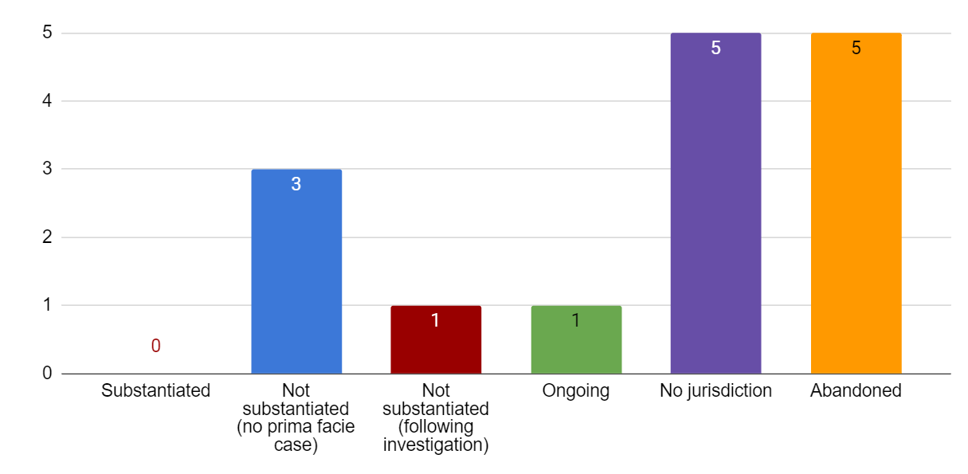

- The 15 requests received in 2019 constitute an increase from previous years. However, the office does not view this increase as indicative of a growing culture of retaliation within UNOPS. Rather, the increase in cases may be attributable to greater visibility of the office, as borne out by the results of the 2019 people survey discussed in section C below. The office has noticed a pattern indicating that multiple requests for protection submitted in any given year will originate from the same office, involve the same subject or be otherwise connected. This was true of six (40 per cent) of the 15 requests received in 2019 (37.5 per cent in 2018, 60 per cent in 2017 and 75 per cent in 2016). The Office also notes that six of the requests received in 2019 relate to allegations of retaliation by a single individual who is not UNOPS personnel.
- In one case, the office found a prima facie case of retaliation and referred the matter to IAIG for investigation. In short, the complainant alleged that the decision to abolish his/her post as part of organizational restructuring and complaints about his/her performance were actually the result of allegations of misconduct made by the complainant. During the investigation, the office agreed on relevant safeguarding measures to protect the complainant with the People and Change Group (PCG). However, the investigation made it clear that both the performance issues and discussions to abolish the complainant’s post pre-dated the protected activity. After reviewing the IAIG investigation report, the office determined there had been no retaliation.
- The office completed a preliminary review in respect of three other requests but found no prima facie case of retaliation. In each case the complainant had reported harassment or abuse of authority by his/her supervisor and alleged that he/she had suffered retaliation as a result. The alleged retaliation took the form of an unfavourable performance assessment in two cases and the abolition of the complainant’s position in the third. For all three cases, the office found the complainant had engaged in a protected activity but, after carrying out interviews and reviewing documentation, considered that no causal connection was established between the protected activity and the detrimental action. One complainant appealed the finding of the office to the Chair of EPUN who upheld the office’s decision and agreed no prima facie case was established.
- Five further requests for protection were withdrawn by complainants. Of the five, two came from former UNOPS personnel who had engaged in protected activities while working for UNOPS; they queried if their engagement in protected activities caused their applications for new positions at UNOPS to be unsuccessful. In respect of the third case, the complainant decided not to take things further after the office had shared with him/her the results of preliminary inquiries. The fourth complainant withdrew the request after resigning from UNOPS. The fifth complainant withdrew his/her request in the light of management action that addressed the underlying issues.
- There were six requests for protection related to the behaviour of a single individual who is not a member of UNOPS personnel but works in the United Nations system. This raised a jurisdictional issue because each organization's policies and procedures assume that the individual requesting protection against retaliation and the alleged perpetrator are assigned to the same United Nations system organization. The office discussed how whistle-blower protection procedures should operate in this scenario with the UNOPS General Counsel and the head of the ethics office of the United Nations system organization concerned. With the consent of the complainants, the office put on hold its preliminary review of five of the requests while the entity employing the individual accused of retaliation took steps to investigate the underlying situation in accordance with its own procedures. In the interim, UNOPS, on the advice of the office, put in place safeguarding measures within UNOPS to afford some protection to the colleagues requesting protection. With regard to the sixth request, the office initiated a preliminary review of the retaliation claim, which was necessarily limited in scope. At the time of writing, the review is ongoing.
- The complainants in each case reported harassment by the individual from the other United Nations organization. In February 2019, UNOPS referred the misconduct complaints to the other United Nations entity, which in turn launched a management review and an investigation. However, the investigation procedures of the other entity differ from those of UNOPS, most notably with regard to its policy to not inform the complainants of the status of the investigation in the way that UNOPS would. In addition, unfortunately UNOPS has found it difficult to obtain information regarding the progress of the different steps and likely timelines, making it challenging to provide reassurance to the UNOPS complainants that the matter is moving forward. UNOPS senior management has been in regular communication with senior management of the United Nations entity in question to express its concerns over the extended length of the process, and it has communicated whatever possible to the UNOPS complainants while supporting them in other ways. Other UNOPS personnel risk finding themselves confronted with the same difficulty in the future, given the number of UNOPS personnel carrying out duties that require them to be in close, if not daily, contact with peers in other United Nations system organizations. The office has identified this as an area requiring EPUN consideration.
Outstanding protection against retaliation requests from 2018
- At the time of submitting its 2018 report, the office had not completed its review of three requests for protection from retaliation and planned to provide details of these cases in the 2019 report.
- All three requests originated in the same office, and two concerned the same individual. In all three cases, the office found there was no causal link between the protected activity and the complainant’s situation, and each situation was due to a combination of management problems and interpersonal issues. In one of the cases, where the complainant had reported fraud, the office took the preventive step, in line with UNOPS policy on protection against retaliation, of alerting the Regional Director to the situation and the risks to the complainant.
Advice
- In 2019, the office advised 11 colleagues on protection against retaliation. In most instances, the colleague sought reassurance about whistle-blower protection either before going on to report misconduct or when feeling exposed, after having engaged in protected activity. None of these cases evolved into a request for protection against retaliation. The remaining cases involved colleagues who were unsure about the definition of protected activity.
Prevention action
- UNOPS policy on protection against retaliation provides that IAIG and PCG will inform the office of any report of wrongdoing received that IAIG or PCG identifies as posing a retaliation risk. The office then consults with the individual about possible preventive action. The provision is helpful as it allows the office to be proactive rather than offering advice to a whistle-blower and then waiting to see if retaliation will materialize.
- The office consulted the General Counsel, IAIG and PCG as to what generic preventive action should be routinely considered. Two generic steps were identified. One method is to ask relevant human resources functions to place a note in the file of the complainant to the effect that the office is to be consulted prior to taking any human resources action which would be adverse to the complainant. The second method consists of alerting senior management, asking them to monitor the situation.
- During 2018, the office was contacted directly by two colleagues who had observed possible misconduct but were afraid of retaliation. The office reminded them of the obligation to report and talked them through the perceived risk of retaliation and the form it might take. The colleagues did report misconduct and IAIG opened an investigation. The office, with the consent of the complainants, took preventive action by contacting the director of the unit in question and briefing him/her of the potential risk identified. No retaliatory action has since been reported.
Policy review
- The current UNOPS policy was issued in 2018 and closely follows that of the United Nations Secretariat (Secretary-General’s Bulletin ST/SGB/2017/2/rev 1 of 28 November 2017). The Joint Inspection Unit (JIU) review of whistle-blower policies and practices in United Nations system organizations (JIU/REP/2018/4) made a number of recommendations, though the United Nations System Chief Executives Board for Coordination noted the need to tailor them to the specific characteristics of the relevant organization. UNOPS engages in continuous review of its policy and procedures to ensure the organization provides effective protection from retaliation. Accordingly, in late 2019 the Chief Ethics and Compliance Officer commissioned an external, independent review of the UNOPS protection against retaliation policy and procedures. The review is being conducted by an international law firm on a pro-bono basis. The Chief Ethics and Compliance Officer discussed this initiative with the members of EPUN, who have expressed interest in learning the results of the review. The review is ongoing and any resulting recommendations will be implemented, where appropriate, in 2020.

Policy and standard setting
- After a peak in 2017 and 2018, the activities of the office regarding policy and standard setting decreased in 2019. This reflects a more established policy environment within UNOPS. Accordingly, in 2019 the office mainly collaborated with other units on standard setting in a broader sense, and laid the groundwork for future initiatives planned for 2020 and beyond.
External reporting platform
- In 2019, the office collaborated with IAIG to establish an external whistle-blowing hotline for the reporting of suspected misconduct, including allegations of retaliation against whistle-blowers. The purpose was to make it simpler for individuals to report concerns by providing a single reporting channel. Under the previous system, an individual needed to report different types of misconduct to different departments; whereas under the new system, cases are automatically assigned to the relevant team for investigation and response based on respective mandates. The office collaborated with IAIG to create a frequently asked questions section accompanying the platform that impresses upon personnel the responsibility to speak up and provides encouragement and reassurance to personnel on how their concerns will be addressed. The system was launched in December 2019.
- The new reporting platform supplements existing reporting channels, but over time it should become the primary method of reporting alleged misconduct.
Preventing Sexual Exploitation and Abuse Working Group
- During 2019, the office continued to field a member to the Prevention of Sexual Exploitation and Abuse Working Group, established by the Executive Director at the end of 2018. The other members of the group are drawn from IAIG, PCG, the Legal Group and the Health, Safety, Social and Environmental Management Team. The working group met eight times in 2019 and carried out a number of initiatives. These included participating in an independent review, by an external party, of the policies and procedures of UNDP, UNFPA and UNOPS for managing sexual exploitation and abuse and sexual harassment and identifying actions to strengthen its implementation. The working group was involved in creating the terms of reference for the new role of field prevention of sexual exploitation and abuse focal points and in communicating with the first incumbents.
Process maps and guidance
- The office developed process maps and guidance in respect of the operational instruction on outside activities, the fourth of the new policies it issued in 2018. This aids understanding of the policy by colleagues who prefer a more visual depiction of the policy provisions.

Training and awareness raising
Training
- Where possible, UNOPS prefers to incorporate ethics into mainstream training courses. This supports efforts to put a culture of ethics at the heart of all UNOPS’ activities. Accordingly, the office’s primary focus for training in 2019 was to collaborate with PCG and the Procurement Group. These two groups run regular training programmes that include a specific ethics session presented by the office. Each ethics session includes practical examples of scenarios that might arise in the context of the issues covered by the wider training course; time is set aside for a question-and-answer discussion with participants at the end. There is high demand for these courses and participants are engaged. The office welcomes the opportunity to collaborate in this way.
- One of the training sessions delivered in this way is a guide to supervisors on how to manage allegations of misconduct. This is now an integral part of two leadership programmes run by PCG with participants from across UNOPS. The office gave the training session four times in 2019, including one session in French.
- The second training session is part of the three-day procurement operations training given by the Procurement Group. The office gave the presentation five times in 2019: to field colleagues in Guinea, Kiev, Nepal, Cambodia and Yangon, both in English and French.
- In 2019, the office developed a training session on conflicts of interest and presented it twice to colleagues based in the Latin America and Caribbean region, once in English and once in Spanish.
- The above training sessions were all given remotely. The office also gave face-to-face training or induction to a number of colleagues visiting UNOPS Copenhagen headquarters from the field. These included interactive sessions at the Finance Group’s retreat and with participants attending a change management course. The office met with 11 field-based human resources colleagues to brief them on the role of the office, with a particular focus on situations when human resources colleagues would need to consult the office. The office also had a briefing session with six colleagues visiting Copenhagen from a field office, which included a discussion about real-life ethical challenges the colleagues face in their roles. Finally, on five occasions the office was invited to give a one-on-one induction session to new colleagues working in a region.
- In the course of 2019, the office contributed to the e-training courses of other units. The Procurement Group developed a new training course that will be mandatory for UNOPS vendors, for which the office collaborated on the ethics section. The office also worked with PCG on an update to their e-learning course for human resources practitioners.
Awareness raising
- The office has taken deliberate steps to raise its visibility in recent years. Previously, UNOPS used to send an integrity, fraud and ethics awareness survey to its personnel every two years; the most recent survey was held in 2017. However, in 2019 UNOPS conducted its biennial people survey and the two surveys were merged. The office welcomed the integration of the two surveys as the people survey has had a high response rate across UNOPS, which helps identify trends and informs the office’s workplan. The office worked with IAIG and PCG in formulating the ethics questions to be included in the survey.
- The results of the 2019 people survey showed an increase in the proportion of respondents (70 per cent) familiar with the ethics helpline, in comparison with 61 per cent in 2017. However, the survey also showed that the level of personnel familiarity with the office was not evenly spread across the UNOPS regions. The results of the survey will be taken into account in planning for 2020.
- With the recruitment of a full-time Chief Ethics and Compliance Officer only completed in the second half of 2019, the office chose to minimize any UNOPS-wide communications during the year. This was to allow the Chief Ethics and Compliance Officer to establish a long-term workplan for the office that would then inform a structured communication strategy.
- At the end of 2019, the office issued year-end guidance to colleagues in all three UNOPS working languages. The message was drafted in positive, plain language and highlighted key points for personnel to remember in respect of their conduct at the end of the year. The message provided a link to a section of the office’s intranet page which contains frequently asked questions on the UNOPS gifts policy. The office worked with the Communications Group to identify the best ways to disseminate the message in order to reach the highest number of colleagues.
- In late 2019, UNOPS redesigned its intranet site. The office updated the ethics-related intranet pages in line with the new protocols and will be developing further the ethics content for the intranet as part of its broader communication strategy in 2020. The office is in discussions with the communications unit and management to enhance visibility of the ethics programme on the intranet in 2020.
- In the course of 2019, the office responded to various requests for assistance in awareness raising. These included reviewing posters intended for a campaign in a UNOPS country office and discussing a planned gender programme with a colleague from a country office, putting her in touch with other colleagues across UNOPS.
- The office also provided ethics advice in relation to key management initiatives. This included reviewing: colleagues proposed for the UNOPS annual project of the year awards; colleagues nominated to join the Network of Peers, which works with PCG to review and address allegations of harassment, discrimination and abuse of authority; and colleagues under consideration for inclusion on the UNOPS talent bench. The office was pleased to assist in these exercises which help ensure consistent messaging across UNOPS.

Financial disclosure programme
2019 cycle
- The office launched the 2019 filing cycle for its financial disclosure and conflict of interest (FDCOI) programme in July 2019. This is one month earlier than in 2018 and follows the plan announced in the 2017 report to progressively bring the launch date forward to an earlier point in the year. This was the tenth annual financial disclosure programme conducted by the office. The office engages an external reviewer to carry out the initial review of submitted FDCOI statements and to gather further information where needed in line with review guidelines issued by the office
- The total number of filers in the 2019 programme was 851, representing approximately 18 per cent of UNOPS personnel.
- At the time of writing this report, 850 of the 851 filers have submitted the FDCOI statement. The outstanding filer held a retainer contract with UNOPS. The individual has been involved in an unrelated internal investigation and his/her services will no longer be retained by UNOPS. The office noted that it continues to see delays on the part of too many filers to either submit the FDCOI statement by the deadline or to respond to follow-up queries sent by the external reviewer in respect of a submitted statement. This puts the organization at risk, as it delays the identification and management of potential conflicts of interest of personnel in key job categories. In addition, the lack of responsiveness by filers results in an extra call on resources, as multiple reminders are sent by the office and line managers, and senior management are asked to intervene. The office took action to address non-compliance in 2019 by implementing financial consequences and will take further steps to increase compliance in 2020. In particular, the office has recommended to PCG that three staff members lose their entitlement to a merit reward which, if financial conditions are met, would be payable in the second half of 2020.
- In 2019 the office, in consultation with IAIG, introduced a new question to capture associations with vendors that were not disclosed in the responses to more specific questions on the form. The office also collaborated with IAIG in respect of two allegations of misconduct that involved statements made on a submitted FDCOI form regarding outside activities.
- The review of the statements filed in the 2019 cycle is ongoing.
Finalization of 2018 cycle
- At the time of writing the 2018 report, the review of the 2018 statements had not been completed. The office has therefore included in this report a summary of the 2018 annual process.
- The office noted at the start of the 2018 review that some filers were disclosing the same situation year on year. This occurs typically with the employment of a family member in the United Nations system or by a UNOPS vendor or partner, which is one of the most prevalent categories of potential conflict of interest identified through the FDCOI process. The external reviewer refers such cases to the office which then follows up directly with filers and their supervisors to ascertain if a situation represents a conflict of interest and to agree on safeguards, as needed and if not already in place, and to remind filers of their obligations regarding conflicts of interest. In order to avoid repetitive questioning of filers, in the review of the 2018 FDCOI statements, the office shared relevant earlier email exchanges with the external reviewer and instructed it, if the same situation was disclosed again, to ask the filer to confirm if there had been any change from the situation described in the previous exchange and to confirm if he/she was still respecting the safeguards and advice given.
- In the review of the 2018 FDCOI statements, 65 cases were referred by the external reviewer to the office. As a result, the office gave advice in respect of conflicts of interest directly to 53 filers. In 31 instances the advice was regarding a family member, 18 cases were in respect of a filer’s outside activities, and four involved reiterating the UNOPS gifts and hospitality policy. All the potential conflicts in respect of family members were resolved in the interests of UNOPS. In several cases, the filer ceased the outside activity in light of the risks pointed out by the office.

Advice and guidance
- The office considers providing advice to personnel on ethical issues an essential tool in UNOPS efforts to grow and strengthen its culture of integrity. The office has worked over the years to build its reputation within UNOPS as a resource available to all UNOPS personnel for practical specialist advice on ethical issues. The office makes it clear to personnel that advice is confidential in order to encourage individuals to come forward with any concerns or questions they may have.
- As a result, requests for advice are becoming the office’s major area. Requests for advice represented 46 per cent of the total services provided in 2019, up from 33 per cent in 2018 and in 2017. The total number of advice requests has also increased by 15 per cent. Figure 4 gives a breakdown of the different categories of advice requested during the year.
Figure 4. Breakdown of subcategories of requests for ethics advice: 2019
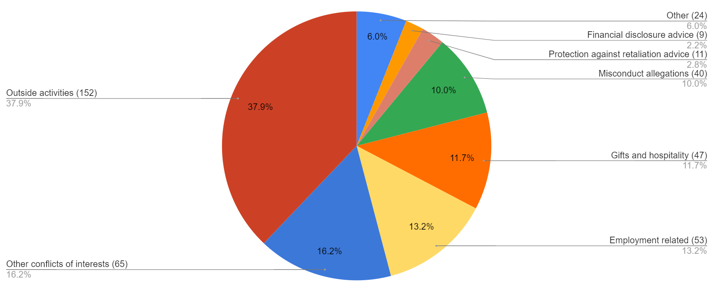

- Outside activities continue to represent a growing area in which the office is asked to advise. UNOPS personnel request approval to engage in a variety of different types of activity. These range from part-time teaching at universities to driving a taxi on the weekend, being a part-time tourist guide or translator, a military reservist, the founder or director of a non-governmental organization, standing for elected office, sitting on various committees, writing and publishing a thesis, publishing an article or giving a speech. While activities such as standing for elected office will always be incompatible with being UNOPS personnel, others will depend on the context and the position held by the individual in UNOPS.
- The office identified a key area in respect of outside activities at the end of 2019 that warrants further action. At least two individuals on retainer contracts (thus with no guarantee of regular assignments with UNOPS but frequently with a UNOPS email address) were also managing directors of a company seeking to do business with UNOPS. One such case was referred to the office for advice at the end of 2019 and was followed by another request in early 2020.
- The office further notes that pursuant to the Standards of Conduct for the International Civil Service, “the primary obligation of personnel is to devote their energies to the work of their organizations”. While UNOPS “should allow, encourage and facilitate the participation of [personnel] in professional activities that foster contacts with private and public bodies and thus serve to maintain and enhance their professional and technical competencies”, it is the view of the office that the level of outside activities is too great, with personnel assuming they will be allowed to undertake outside activities rather than it being the exception. The Chief Ethics and Compliance Officer will discuss tightening the UNOPS approach with the Executive Director in 2020.
- The office is also frequently called on to provide advice in respect of other types of conflict of interest. These fall broadly into two categories. The first relates to the personal situation of an individual member of UNOPS personnel, frequently coming to light through the FDCOI filing programme. In these cases, the office reviews the situation with the individual’s supervisor to assess what safeguards should be put in place to protect the interests of UNOPS. The office will then write directly to the individual explaining the risks and safeguards. The other type of conflict of interest case covers a variety of situations where a member of UNOPS personnel faces a dilemma in respect of a situation at work and needs advice to work through the options.
- One particular trend apparent in 2019 was that colleagues are increasingly approaching the office for advice before making an allegation of misconduct or, in some cases, seeking advice from the Office of the Ombudsman for United Nations Funds and Programmes. In these situations, the office is able to advise about rights and obligations when reporting misconduct and what to expect. Again, in this case, the confidential nature of advice has helped to draw people out who might otherwise have remained silent.

Other
- The office participated in an exercise run by the Chief Information Security Officer to verify that the types of information kept by the office are being stored in systems with the appropriate levels of security, given the classification of the information in question. This was a two-stage process that consisted, first, in creating an information asset inventory and, second, in classifying the information and the security of the systems used. The process was comprehensive and covered the FDCOI filing system, the terms of UNOPS contract with the external reviewer of the FDCOI statements, access to emails, and physical documents kept in offices.

Development of the Ethics and Compliance Office, 2019-2020
- As noted in the introduction, with the arrival of the Chief Ethics and Compliance Officer, the office has been able to begin developing its plans to build an enhanced ethics programme and the new compliance programme. During 2019, the office consulted with a wide selection of stakeholders within UNOPS and conducted external benchmarking as it began developing its strategic plan, a new day-to-day definition of ethics at UNOPS, and description of the role of the office within UNOPS. The team also held its inaugural two-day team-building workshop, facilitated by the UNOPS change management team.
- The office is now following a detailed workplan to advance its strategic objectives, which includes activities for both 2019 and 2020. The workplan addresses five key areas:
  - continued delivery of existing ethics programme work;
  - activities to enhance existing ethics activities;
  - development of the new ethics programme, increasing focus on institutional integrity;
  - development of the new compliance programme; and
  - supporting the wider United Nations system on ethics and compliance.
- During 2019, steps were taken to make progress on item (b), including commissioning an independent review of the office’s protection against retaliation measures through the introduction of a single case/project management tool to align with IAIG and the development of new quarterly reporting to the senior leadership team. During 2020, the workplan includes a number of ambitious and innovative activities, including the conducting of a global ethics risk assessment, the introduction of new communications and training programmes, and steps to enhance accountability within UNOPS through a new compliance programme.

The Ethics Panel of the United Nations and the Ethics Network of Multilateral Organizations
Ethics Panel of the United Nations (EPUN)
- The previous head of office participated in EPUN monthly meetings throughout 2019, with the Chief Ethics and Compliance Officer joining from August 2019. Composed of the heads of ethics offices of the United Nations Secretariat and the funds and programmes, and chaired by the Director of the United Nations Ethics Office, EPUN is mandated to establish a unified set of ethics standards and policies and to consult on complex ethics matters having system-wide implications. Additionally, acting as EPUN Alternate Chair pro tem, the Chief Ethics and Compliance Officer conducted one review of the contested protection against retaliation findings from the United Nations Ethics Office.
Coherence
- Throughout 2019, the office continued to engage with other funds and programmes to share best practice and experience. Much of this interaction is related to comparison of policies and procedures between organizations. In particular, several organizations sought further information or input from UNOPS on the new financial disclosure procedure first introduced in 2016. Colleagues from other organizations were interested to learn more about how the changes had streamlined the process for UNOPS and other benefits.
Ethics Network of Multilateral Organizations
- As a member of the Ethics Network of Multilateral Organizations (ENMO), the office attended the ENMO annual meeting in Munich in July 2019. At the meeting, the office co-chaired a working session on protection against retaliation and was elected as a member of the ENMO membership committee.
Support to other organizations
- Since 2017, the office has been the outside reviewer of requests for review by personnel of the World Intellectual Property Organization (WIPO) with regard to determinations by the WIPO Ethics Officer in whistle-blower cases. In 2019, the office reviewed four requests from WIPO personnel. These consisted of two cases received at the end of 2018, plus two new cases. In all instances, the office reviewed and rejected the appeals.

Key to categories Protection against retaliation: Requests for protection against retaliation and proactive steps taken to reduce likelihood of retaliation. Policy and standard setting: Initiatives with respect to ethics policies, collaboration with other units on related policies, work carried out to meet Joint Inspection Unit recommendations. Training and awareness raising: Creation, collaboration on and delivery of training; and internal communications. FDCOI programme: Administration of annual programme. Coherence: Collaboration and information sharing with EPUN and other multilateral organisations. Supporting other organizations: Review of protection against retaliation and other decisions by other organizations. Office alerted: Contact to the Ethics Office regarding matters falling outside its role and referred onward.
Key definitions Employment-related: Includes advice given on ethical issues in relation to recruitment, employment and post-employment restrictions. Misconduct allegations: Includes advice given on duties and options in circumstances of possible misconduct and collaboration with IAIG on same. Financial disclosure advice: Relates to advice on obligations to file, not the annual FDCOI process itself. Protection against retaliation advice: Refers to advice regarding protection against retaliation but not formal steps taken to provide protection.

